Project Development Phase
Model Performance Test

Date | 26 October 2025
Team ID | NM2025TMID02641
Project Name | Educational Organisation Using ServiceNow
Maximum Marks

Model Performance Testing:
1. Objective
The objective of this phase is to evaluate the performance, reliability, and efficiency of the Educational Organisation Using ServiceNow application. It ensures that the system performs smoothly under expected workloads and meets all functional requirements without any delay or data inconsistency.
2. Scope
The performance testing focuses on verifying how the system handles multiple operations such as student registration, faculty management, and helpdesk ticket handling. The main goal is to identify and fix performance bottlenecks in the ServiceNow workflows, forms, and data tables.
3. Modules Tested
Module Name | Description | Testing Performed | Result
Admission Module | Handles student admission details like admission number, date, grade, purpose of joining, parent details, and school details. | Checked for record creation, field validation, state transitions (New → In Progress → Joined → Closed). | Successfully Passed
Salesforce Module | Manages student registration and parent contact information. | Verified form submission, record saving speed, and auto-generated admission number. | Successfully Passed
Student Progress Module | Records marks for subjects such as Telugu, Hindi, English, Maths, Science, and Social. Automatically calculates total, percentage, and result. | Tested calculations, data saving accuracy, and display of results. | Successfully Passed

Screenshots of Tested Modules :
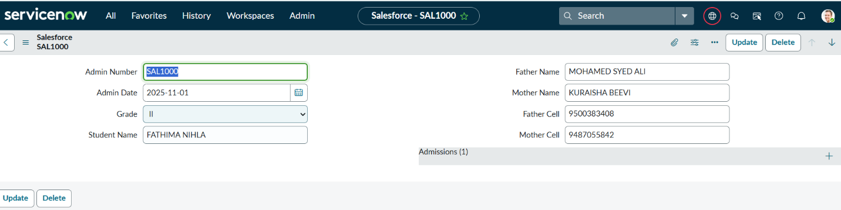

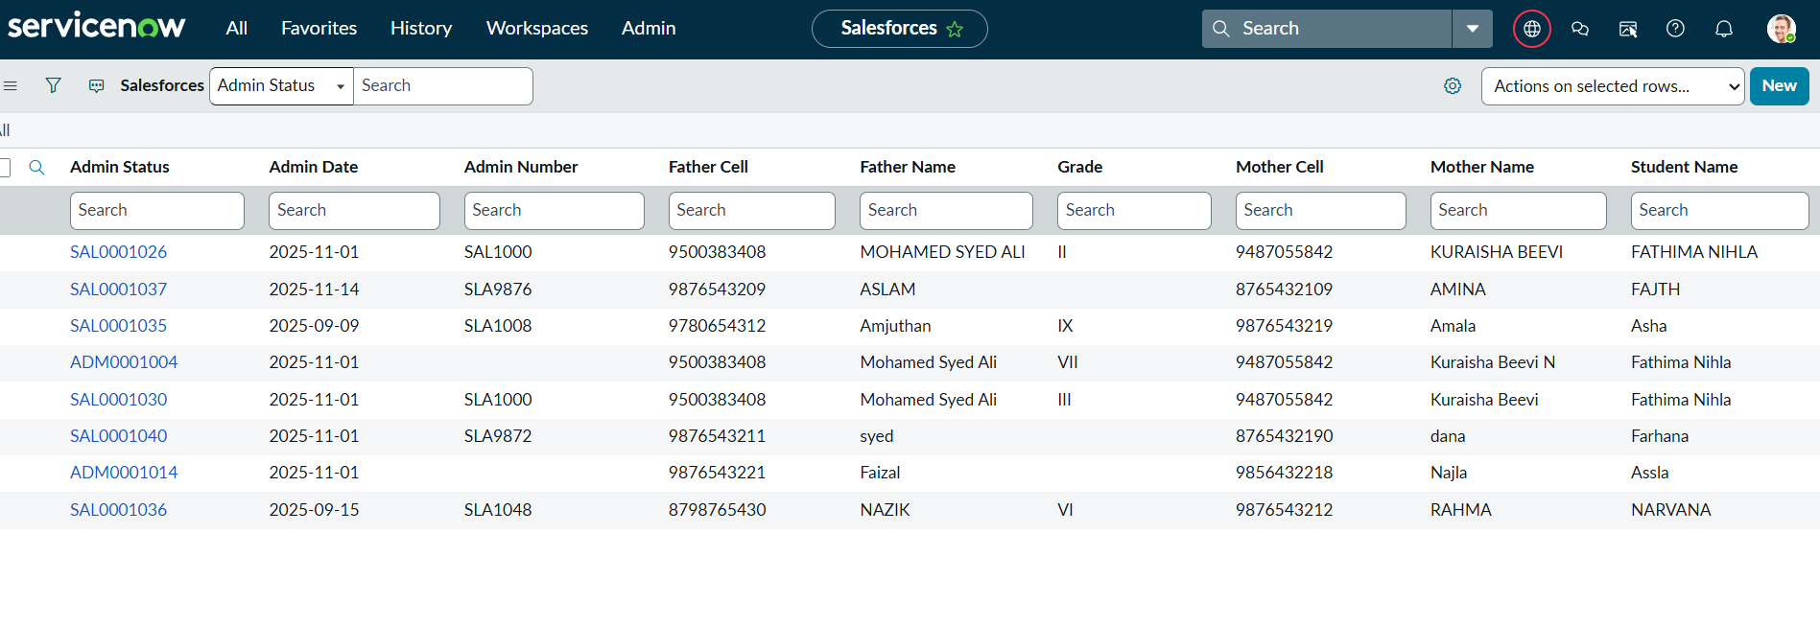
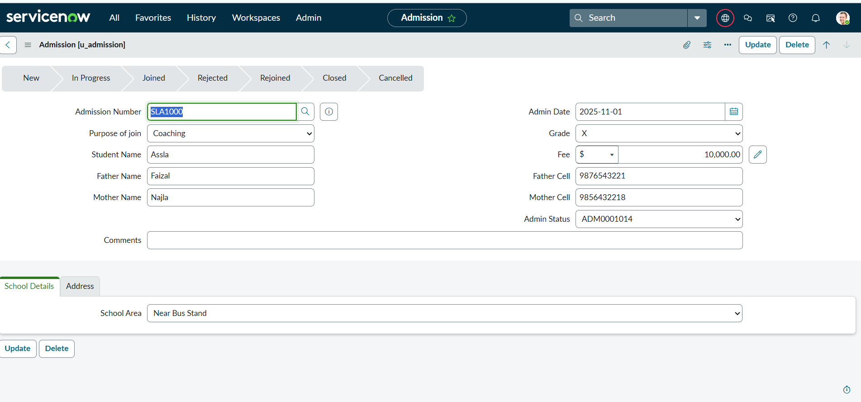

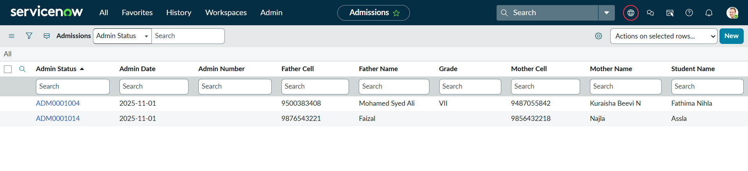

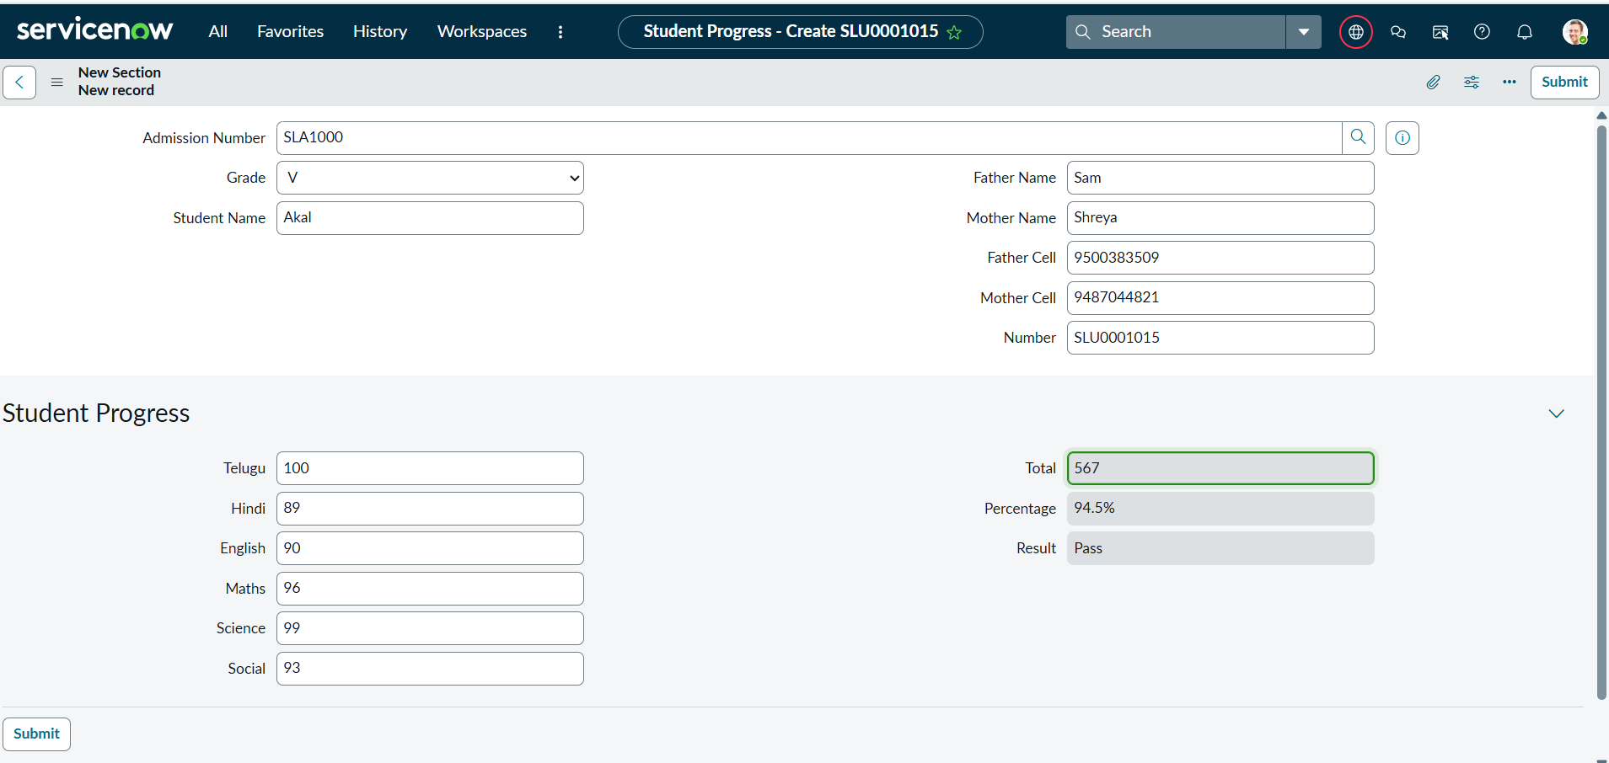

4. Testing Parameters
Parameter | Description | Observation
Response Time | Time taken for each form to load and submit. | All forms loaded within 2–3 seconds.
Data Accuracy | Verification of correct data saving and retrieval in ServiceNow tables. | All entries saved correctly without duplication.
Workflow Execution | Ensuring state transitions and Flow Designer automation worked properly. | All flows executed successfully.
Scalability | Tested by adding multiple student entries. | System remained stable and responsive.
Reliability | Checked for errors or crashes during multiple submissions. | No failures detected.

5. Tools and Platform Used
Layer | Technology/Module
Platform | ServiceNow (Personal Developer Instance - PDI)
UI | Form-based Modules
Logic | Client Scripts, UI Policies
Database | ServiceNow Tables
Deployment | Cloud-based via ServiceNow PDI
Testing | Manual Testing & Performance Testing within ServiceNow

7. Outcome

The Educational Organisation Using ServiceNow project successfully passed all performance testing criteria. The application demonstrated stable performance, fast response time, and accurate workflow execution. This confirms the system’s readiness for deployment and end-user usage.

